Database System and ER Diagrams
Course Registration

Table 1: Students
StudentID(PK) | FullName | Email | Major
100 | Asmin Kandel | asmin@semo.edu | Computer Science
101 | Apsana Poudel | apsana@semo.edu | Business
102 | Lilly Brown | lilly@semo.edu | Chemistry
103 | Alexis Wilson | alexis@semo.edu | Mathematics
Primary Key – StudentID

Table 2: Instructors
InstructorID(PK) | FullName | Department | Location
301 | Dr. Jack Newton | Computer Science | Dempster Hall 101
302 | Eva Dove | Business | Rhodes Hall 204
303 | Sophia Martinez | Chemistry | Magill Hall 300
304 | Jason Cooper | Mathematics | Johnson Hall 404
Primary Key: InstructorID

Table 3: Sections
SectionID(PK) | CourseTitle | InstructorID(FK) | Semester
500 | Introduction to Computer Science | 301 | Fall 2026
501 | Foundation of Business | 302 | Fall 2026
502 | General Chemistry | 303 | Fall 2026
503 | Applied Calculus | 304 | Fall 2026

Primary Key- SectionID
Foreign Key: InstructorID → Instructors.InstructorID

Table 4: Enrollment
EnrollmentID(PK) | StudentID(FK) | SectionID(FK) | EnrollmentDate
600 | 100 | 500 | 08-10-2026
601 | 101 | 501 | 08-11-2026
602 | 102 | 502 | 08-12-2026
603 | 103 | 503 | 08-13-2026
Primary Key: EnrollmentID
Foreign Key: StudentID → Students.StudentID
Foreign Key: SectionID → Sections.SectionID

3.Schema
- Students (StudentID, FullName, Email, Major)
- Instructors (InstructorID, FullName, Department, Location)
- Sections (SectionID, CourseTitle, InstructorID, Semester)
- Enrollment (EnrollmentID, StudentID, SectionID, EnrollmentDate)
Instance
Table 1: Students
StudentID | FullName | Email | Major
100 | Asmin Kandel | asmin@semo.edu | Computer Science
101 | Apsana Poudel | apsana@semo.edu | Business
102 | Lilly Brown | lilly@semo.edu | Chemistry
103 | Alexis Wilson | alexis@semo.edu | Mathematics

Table 2: Instructors
InstructorID | FullName | Department | Location
301 | Dr. Jack Newton | Computer Science | Dempster Hall 101
302 | Eva Dove | Business | Rhodes Hall 204
303 | Sophia Martinez | Chemistry | Magill Hall 300
304 | Jason Cooper | Mathematics | Johnson Hall 404

Table 3: Sections
SectionID | CourseTitle | InstructorID | Semester
500 | Introduction to Computer Science | 301 | Fall 2026
501 | Foundation of Business | 302 | Fall 2026
502 | General Chemistry | 303 | Fall 2026
503 | Applied Calculus | 304 | Fall 2026

Table 4: Enrollment
EnrollmentID | StudentID | SectionID | EnrollmentDate
600 | 100 | 500 | 08-10-2026
601 | 101 | 501 | 08-11-2026
602 | 102 | 502 | 08-12-2026
603 | 103 | 503 | 08-13-2026

4.

Constructs and Constraints

1. Students
- Construct: The Students table helps to stores the information about students, with their student ID, name, email, and major.
- Constraint: StudentID must be unique because it is the primary key and it cannot be empty.

2. Instructors
- Construct: The Instructors table stores information about the instructors, including their instructor ID, name, department, and location.
- Constraint: InstructorID must be unique because it is a primary key and it cannot be empty.

3. Sections
- Construct: The Sections table stores information about courses offered in a semester, including the course title, section ID, instructor, and semester.
- Constraint: InstructorID must exist in the Instructors table. This maintains the referential integrity.

4. Enrollment
- Construct: The Enrollment table stores information about which students are registered for which course sections.
- Constraint: StudentID must exist in the Students table, and SectionID must exist in the Sections table. This maintains referential integrity.

Architecture Reflection
In a client-server architecture, the course registration database would be stored on a central server. Students will be using either a website or an application client in order to browse and choose the courses to register. On the other hand, university staff members and instructors can also use the system for viewing of information regarding students and the courses offered.

Part 2:

1.Short Story
The system used in our university to conduct course registrations allows students to register for the courses offered in any semester. Each student has a unique StudentID along with a name, email address, and Major. Each instructor also has a unique InstructorID, name, department, and location. Furthermore, every course section carries its own unique SectionID, course title, and semester. One instructor can teach many course sections, but each individual section is assigned to exactly one instructor. Many of the students can enroll in the same course section, and a single student can register for multiple sections at once. The system tracks these registrations using an enrollment record that captures the specific date the student is signed up for.

2.
- Entity 1: Students[ StudentID(PK), FullName, Email, Major]
- Entity 2: Instructors[ InstructorID(PK), FullName, Department, Location]
- Entity 3: Sections[ SectionID(PK), CourseTitle, InstructorID(FK), Semester]
- Entity 4: Enrollment[ EnrollmentID(PK), StudentID(FK), SectionID(FK), EnrollmentDate]

Relationships:
There are 2 relationships:
- ENROLLS: It connects STUDENT and SECTION. Cardinality (M:N) and attribute is EnrollmentDate.
- TEACHES connects INSTRUCTOR and SECTION with cardinality (1:N)

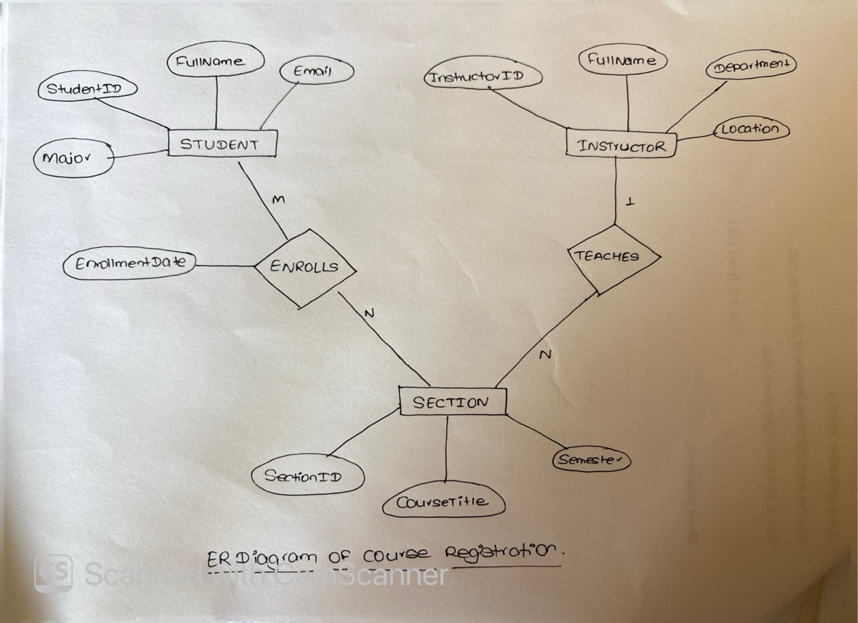

3.Key and Constraints

Primary Keys
- StudentID is the primary key of STUDENT.
- InstructorID is the primary key of INSTRUCTOR.
- SectionID is the primary key of SECTION.

Foreign Keys
In the relational database:
- Sections.InstructorID → Instructors.InstructorID
- Enrollment.StudentID → Students.StudentID
- Enrollment.SectionID → Sections.SectionID

Cardinalities
- STUDENT - ENROLLS - SECTION = M:N
- INSTRUCTOR - TEACHES - SECTION = 1:N

Constraints
- StudentID must be unique and cannot be empty.
- InstructorID must be unique and cannot be empty.
- SectionID must be unique and cannot be empty.
- Every InstructorID in Sections must exist in the Instructors table.
- Every student enrolled in a section must have a valid StudentID.
- Every enrolled section must have a valid SectionID.
I have updated my original database by adding an Enrollment table to record which students are registered for which course sections. The Enrollment table also includes EnrollmentID, StudentID, SectionID, and EnrollmentDate. In the ER diagram, the enrollment information is represented by the ENROLLS relationship between STUDENT and SECTION, with EnrollmentDate as an attribute of the relationship. This modification allows the database to represent the many-to-many relationship between students and course sections.

